Probing Neural Network Fragility: An Experimental Analysis of Gradient-Based Adversarial Attacks and Robustness Hardening via Adversarial Training

Gaurav Sharma , Dr.Sreevani Maddukuri
Gaurav Sharma (student), INT.Mtech CSE Spec. Cyber Security, VIT Bhopal Dr.Sreevani Maddukuri(supervisor), Dr. Hemraj .S.Lamkuche(reviewer 1),Puspinder Singh Patheja(reviewer 2), School of Computing Science Engineering and Artificial Intelligence, VIT Bhopal

ABSTRACT
Deep learning has reshaped how software systems perceive, interpret, and act upon raw data. Yet alongside these advances lies an inconvenient reality: the very mathematical machinery powering state-of-the-art classifiers can be turned against them. Targeted pixel-level modifications — engineered rather than accidental — can silently redirect a model's predictions while passing unnoticed by any human reviewer. This mismatch between machine fragility and human perception is not a minor edge case; it is a structural property of gradient-driven learning that demands direct examination.
This paper documents a controlled experimental study of gradient-based adversarial attacks on a convolutional image classifier. A purpose-built CNN was trained to categorize CIFAR-10 images, then probed using the Fast Gradient Sign Method (FGSM) across four perturbation budgets. The results were stark: accuracy that stood at 72.54% on clean inputs collapsed to single digits under moderate perturbation, underscoring just how brittle an unprotected network can be against a knowledgeable adversary.
To counter this fragility, adversarial training was applied — a strategy that weaves hostile inputs directly into the learning process so the model confronts its own weaknesses during training. The hardened model retained substantially higher accuracy under attack across all tested perturbation levels, with the improvement reaching over 21 percentage points at the benchmark budget of ε = 0.03. Multi-budget robustness profiling, confusion matrix diagnostics, and visual inspection of perturbed samples all corroborate the defense's practical value.
Taken together, the findings make a compelling case that threat-aware training is not optional engineering — it is an essential design discipline for any neural system deployed where adversarial conditions are plausible.

Introduction
Over the past decade, machine learning has graduated from a research curiosity into critical infrastructure. Neural networks now underpin medical diagnosis tools, autonomous navigation stacks, fraud detection pipelines, and content moderation systems. This rapid assimilation reflects genuine capability gains — but it also means that failures carry real-world consequences that extend well beyond benchmark leaderboards. What is less frequently acknowledged in deployment discussions is how systematically these systems can be deceived. An adversary who understands gradient-based optimization can craft inputs that redirect a classifier's output with surgical precision. This offensive use of the same mathematics that powers training — flipping the sign of a gradient update to maximally confuse rather than improve — gives rise to a class of attacks that exploit deep networks' own internal geometry against them.

The same technology engineered to solve problems becomes, in adversarial hands, a mechanism for producing targeted failures. Threat categories span the full model lifecycle: data poisoning corrupts learning before training ends; model inversion and membership inference expose private training records; model extraction reconstructs proprietary functionality through query access; and input-level adversarial attacks operate at inference time, targeting deployed systems directly.
Input-level adversarial attacks occupy a particularly concerning position in this threat landscape. They require no privileged access to model internals — only the ability to supply inputs — and they produce failures that are invisible under normal inspection. A network that classifies a stop sign with 99% confidence can be made to misidentify that same sign with equally high (but wrong) confidence after modifications that no human reviewer would flag. This dissonance between machine confidence and correctness is precisely what makes adversarial inputs dangerous in safety-critical deployments.
This study approaches the problem empirically. Rather than contributing new theoretical bounds, it demonstrates — through careful measurement — how vulnerable a standard CNN becomes under gradient-sign perturbation and how much of that vulnerability adversarial training can reclaim. All experiments use the CIFAR-10 benchmark, a controlled environment where clean-image performance serves as a stable reference point from which adversarial degradation can be precisely quantified. Evaluation spans clean accuracy, per-epsilon adversarial accuracy, confusion matrix structure, and direct visual inspection of perturbed samples.
The primary contributions of this work are as follows:
- Development of a CNN-based image classification model using the CIFAR-10 dataset. Implementation and evaluation of FGSM adversarial attacks under multiple perturbation levels.
- Investigation of adversarial training as a defense mechanism against adversarial attacks.
- Comparative analysis of standard and robust models using quantitative and visual evaluation metrics.
- Discussion of the security implications of adversarial attacks and the importance of robust AI systems.
The findings of this study contribute to the growing field of AI security by demonstrating both the vulnerabilities of deep learning models and the effectiveness of defensive strategies for mitigating adversarial threats.

Literature Review
The security of learned models has attracted sustained research attention as neural networks moved from experimental settings into production deployments. Initial work established that even high-performing classifiers possess decision boundaries with unexpected geometric properties — surfaces that lie close to the data manifold but in directions that human perception ignores entirely. This gap between human perceptual stability and machine sensitivity forms the foundation of adversarial machine learning. A perturbation constrained to be small under any standard image norm can nonetheless push a test point across a decision boundary, producing an arbitrarily wrong prediction with high model confidence. The phenomenon is not architecture-specific: it appears across diverse model families and generalizes across different training sets, suggesting it reflects something fundamental about how high-dimensional classifiers partition input space. The Fast Gradient Sign Method (FGSM) introduced a practical approach for generating adversarial examples by utilizing gradient information from

the target model. Since its introduction, FGSM has become one of the most commonly used benchmark attacks for evaluating model robustness due to its simplicity and computational efficiency. Researchers have used FGSM extensively to study the behavior of neural networks under adversarial conditions and to measure the vulnerability of different architectures. Researchers subsequently developed iterative variants that apply smaller gradient-sign steps multiple times within a constrained perturbation budget, consistently finding that iteration produces stronger attacks. Optimization-based formulations further generalized the approach by targeting specific misclassification outcomes or minimizing perceptibility under alternative distance norms. Across all these attack families, a consistent finding emerged: raw classification accuracy on clean data provides essentially no information about a model's vulnerability under adversarial conditions. On the defensive side, data augmentation with adversarial samples has proven the most empirically reliable intervention. By embedding attack examples directly in the training distribution, the model is forced to maintain consistent predictions across input neighborhoods rather than committing to isolated high-confidence regions. The cost of this approach is a modest reduction in clean-data performance — a tradeoff that reflects the fundamental tension between interpolation fidelity and neighborhood consistency. Multiple independent replication studies have confirmed this pattern, establishing it as a stable empirical finding rather than an artifact of specific implementation choices. The adversarial input literature sits within a broader AI security ecosystem that encompasses training-time threats (data poisoning, backdoor injection), model-level threats (extraction via query access, inversion of training data), and output misuse (synthetic media generation for disinformation). This multi-surface threat landscape reinforces that security cannot be addressed through a single intervention — it must be woven into every stage of the development and deployment pipeline. While the theoretical literature on adversarial robustness has matured considerably, experimentally grounded studies that trace the full arc from baseline training through attack evaluation to defense comparison remain valuable for practitioners. This work provides such a study: a reproducible, measurement-focused comparison of standard and adversarially trained CNNs under FGSM conditions, documented with quantitative tables, robustness curves, confusion matrices, and visual adversarial examples.
.

Methodology
The experimental pipeline was designed to isolate the variables of interest: architecture, perturbation budget, and training strategy. By holding architecture constant and varying only whether adversarial examples appeared during training, the performance difference between models can be attributed directly to the training procedure rather than capacity differences.

Dataset
CIFAR-10 was selected as the experimental substrate. The dataset provides 60,000 color images — each 32×32 pixels across three channels — drawn from ten visually distinct object categories. Its canonical train/test partition (50,000 / 10,000) enables reproducible evaluation without data-leakage concerns, and its moderate complexity makes perturbation effects clearly measurable without requiring specialized hardware.
The ten classes included in the dataset are:
* Airplane
* Automobile

* Bird
* Cat
* Deer
* Dog
* Frog
* Horse
* Ship
* Truck
Data loading was handled by the Torchvision library's built-in CIFAR-10 downloader. Images were converted to floating-point tensors and pixel values normalized to the [0, 1] range prior to being consumed by the network.

Convolutional Neural Network Architecture
A compact convolutional network was implemented as the shared backbone for all experiments. The architecture was intentionally kept shallow — two convolutional blocks followed by a two-layer classification head — to ensure that any robustness differences between the standard and adversarially trained models reflect the training strategy rather than excess model capacity.
The model architecture is summarized below:
- Convolution Layer 1: 3 input channels, 32 output channels, kernel size 3×3.
- Convolution Layer 2: 32 input channels, 64 output channels, kernel size 3×3.
- Max Pooling Layer: Pool size 2×2.
- Fully Connected Layer 1: 4096 input features and 512 output features.
- Fully Connected Layer 2: 512 input features and 10 output classes.
Both the standard and robust variants were optimized using Adam (learning rate 0.001) with Cross-Entropy Loss as the training objective. Keeping these hyperparameters identical ensures that robustness differences stem from data composition, not optimization choices.

Fast Gradient Sign Method (FGSM)
FGSM was selected as the attack method for its computational transparency and widespread use as an evaluation standard. It constructs adversarial inputs by computing the gradient of the classification loss with respect to the input image and displacing each pixel by ε in the direction that maximally increases loss:
x_adv = x + ε · sign(∇_x L(θ, x, y))
where:
• x — original input image (clean)
• x_adv — adversarially modified image
• ε — perturbation budget controlling attack strength

* J represents the loss function.
* θ represents model parameters.
* y represents the true label.
Pixel values were clamped to [0, 1] after perturbation to preserve valid image range. Four budget values were evaluated — ε ∈ {0.01, 0.03, 0.05, 0.10} — spanning from visually imperceptible to mildly noticeable perturbation.

Adversarial Training
To harden the model against gradient-based attacks, the training procedure was modified to include adversarially perturbed samples. For each mini-batch during training, FGSM perturbations at ε = 0.03 were generated on-the-fly, and the combined loss over both clean and perturbed copies drove the parameter updates:
L_total = L(θ, x, y) + L(θ, x_adv, y)
This dual-objective formulation penalizes the model for misclassifying either form of each training sample, forcing it to build decision boundaries that are more stable under small input displacements. All other training settings (optimizer, learning rate, epochs, batch size) remained identical to the baseline.

Evaluation Metrics
The performance of the proposed system was evaluated using the following metrics:
- Classification Accuracy
- Adversarial Accuracy
- Multi-Epsilon Robustness Analysis
- Confusion Matrix Evaluation
- Visual Analysis of Adversarial Examples
These metrics provide both quantitative and qualitative insights into model performance, vulnerability, and robustness under adversarial conditions.

Experimental Setup
  - Development Environment
All experiments ran within an isolated Python 3.x virtual environment on a Windows workstation, with Visual Studio Code as the development environment. The complete software stack consisted of PyTorch for model construction and gradient computation, Torchvision for dataset handling, NumPy for array operations, Matplotlib for visualization, and Scikit-learn for confusion matrix generation.
The primary software components used in this research include:
* Python 3.x
* PyTorch
* Torchvision
* Matplotlib

* NumPy
* Scikit-learn

Dataset Configuration
CIFAR-10 was fetched automatically by Torchvision's dataset API on first execution and cached locally. The 50,000 training / 10,000 test split was preserved as-is, with no cross-validation or data augmentation applied to the baseline configuration.
Each image was converted to a floating-point tensor with pixel values in [0, 1] before being passed to the network. No normalization beyond this scaling was applied, keeping preprocessing minimal and the experimental setup transparent.

CNN Training Configuration
The standard model was trained under the following configuration:

Parameter | Value
Optimizer | Adam
Learning Rate | 0.001
Loss Function | Cross Entropy Loss
Batch Size | 32
Dataset | CIFAR-10
Training Images | 50,000
Testing Images | 10,000

After ten epochs, the baseline model reached a clean test accuracy of 72.54%, establishing a stable reference point for subsequent adversarial evaluation.

FGSM Attack Configuration
FGSM was applied at inference time to generate adversarial test sets for each perturbation budget. Model weights were frozen during attack generation — no training occurred during this evaluation phase.
Perturbation budgets evaluated: ε ∈ {0.01, 0.03, 0.05, 0.10}
0.01, 0.03 ,0.05,0.10

These four values span a range from visually imperceptible (0.01) to faintly perceptible (0.10), allowing the degradation curve to be characterized across a meaningful threat spectrum.
The robust model was produced by modifying the training loop to expose the network to FGSM-perturbed inputs alongside clean images throughout all ten training epochs.
The final robust model was trained using:

Parameter | Value
Adversarial Attack | FGSM
Training Epsilon | 0.03
Epochs | 10
Optimizer | Adam
Learning Rate | 0.001
Loss Function | Combined Clean And Adversarial Loss

After training, the robust model was evaluated on the same test partition and under the same attack configurations as the baseline, enabling a direct, controlled comparison between the two training strategies.

Generated Artifacts
Several artifacts were generated during experimentation for analysis and visualization:
* Epoch Accuracy Graph
* FGSM Accuracy Comparison Graph
* Multi-Epsilon Robustness Graph
* Adversarial Example Visualization
* Robust Adversarial Example Visualization
* Confusion Matrix
These artifacts provide both numerical and visual evidence of model behavior under adversarial conditions.

Results and Discussion
  - Baseline CNN Performance
Training was monitored epoch-by-epoch to confirm stable convergence before any adversarial evaluation began.

The model achieved a test accuracy of:

72.54%
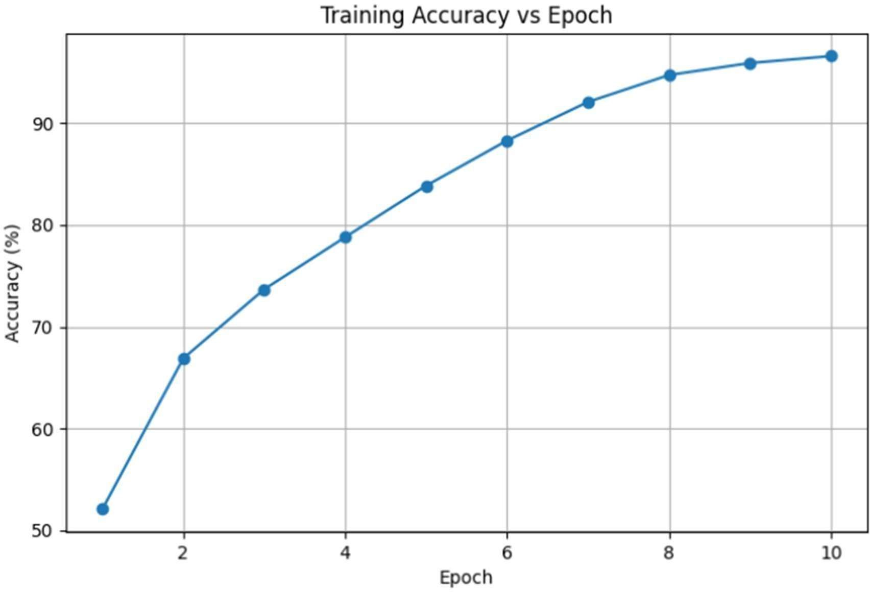
Figure 1. Training Accuracy of CNN Across Training Epochs
A clean test accuracy of 72.54% confirms that the network acquired genuinely discriminative representations — sufficient to serve as a meaningful baseline whose degradation under attack will be clearly interpretable.

Impact of FGSM Adversarial Attacks
With the baseline established, FGSM attacks were launched across four perturbation budgets. The results expose a steep accuracy cliff:
The classification accuracy of the baseline CNN under adversarial conditions is shown below.

Epsilon | Accuracy(%)
0.01 | 23.13
0.03 | 7.34
0.05 | 3.35
0.10 | 1.04
The degradation is both rapid and severe. At ε = 0.03 — a perturbation budget smaller than what standard JPEG compression typically introduces — accuracy plummeted from 72.54% to 7.34%. A network that was confidently correct on nearly three quarters of clean images became nearly indistinguishable from a random guesser after a single gradient-sign step.

This collapse was not a fluke of a particular epsilon: the monotonically worsening figures across all four budgets confirm a systematic structural vulnerability, not an isolated failure mode.

Adversarial Example Analysis
Examining individual adversarial examples confirmed what the aggregate numbers implied: the perturbed images are visually indistinguishable from their originals under normal viewing conditions, yet the network's prediction flips entirely.
In one experimental example:
* Original Prediction = 3
* Adversarial Prediction = 5
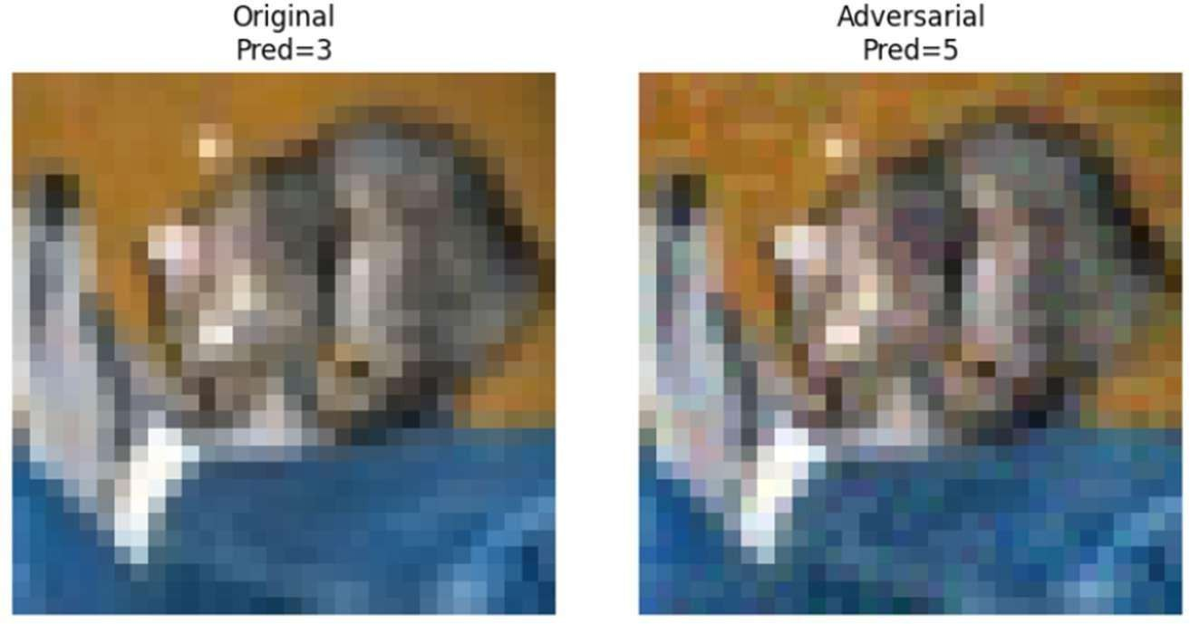
Figure 4. Successful FGSM Attack Causing Prediction Change
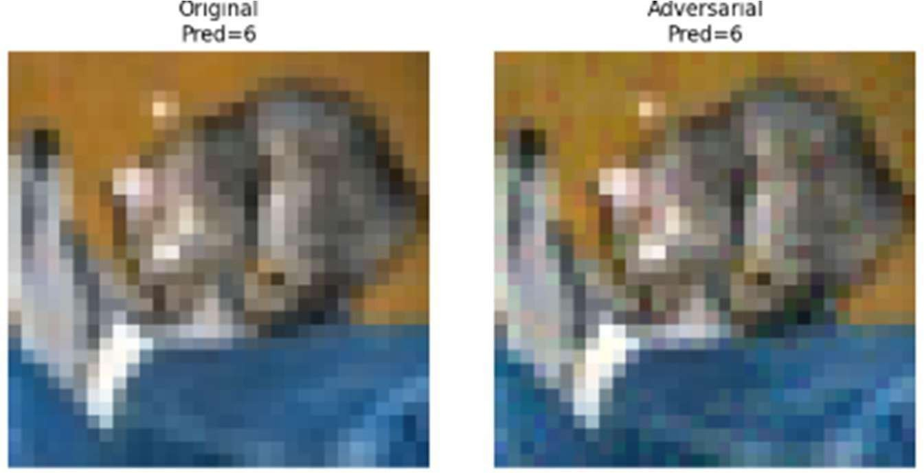
Figure 5. Robust CNN Preserving Prediction Under FGSM Attack
While the standard model failed on the adversarial version, the robustly trained model maintained the correct prediction under the same perturbation — a concrete illustration of how adversarial training narrows the gap between clean and adversarial behavior.
The imperceptibility of the perturbation is precisely what makes this threat operationally significant: there is no visual signal that an input has been tampered with, yet the model's entire prediction changes.

Adversarial Training Performance

To improve robustness, adversarial training was implemented. The final adversarial trained model achieved:

65.15% Classification Accuracy
Although the accuracy was lower than the baseline CNN, the model demonstrated substantially improved resistance to adversarial attacks.
This clean-accuracy cost is the price of robustness. The key question is whether the trade is worthwhile — and the adversarial accuracy figures answer it decisively.

Robustness Evaluation of the Adversarial Trained Model
When subjected to the same FGSM attacks, the robust model showed dramatically better resilience:

Epsilon | Robust Accuracy (%)
0.01 | 49.87
0.03 | 28.38
0.05 | 16.09
0.10 | 4.63

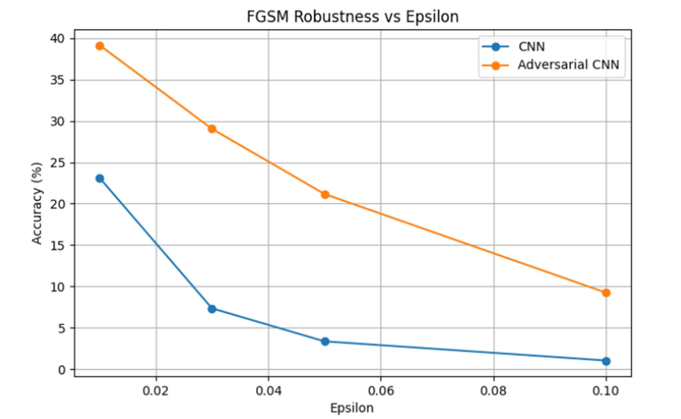

Figure 6. FGSM Accuracy Comparison Between Standard CNN and Adversarial Trained CNN.
At ε = 0.03 — the midpoint of the evaluated range and the training budget for the robust model — accuracy improved from 7.34% to 28.38%, a 21-percentage-point gain representing nearly a fourfold improvement. The gains extend across all four tested budgets, indicating that robustness generalizes beyond the exact training epsilon rather than being narrowly tuned.

For example: * Baseline CNN at ε = 0.03 → 7.34%
* Robust CNN at ε = 0.03 → 28.38%
This demonstrates the effectiveness of adversarial training in improving model resilience

Metric | Standard CNN | Robust CNN
Clean Accuracy | 72.54% | 65.15%
FGSM Accuracy (ε=0.03) | 7.32% | 28.38%

The accuracy-robustness tradeoff observed here — lower clean performance, substantially higher adversarial performance — is a well-documented characteristic of adversarial training. Rather than viewing this as a deficiency, it is better understood as a deliberate calibration: the robust model allocates its representational capacity toward stability rather than peak interpolation.
The robust model sacrificed a portion of clean accuracy in exchange for significantly improved adversarial robustness. This tradeoff is consistent with observations reported in existing adversarial machine learning literature.

Confusion Matrix Analysis

A confusion matrix was generated to analyze class-level prediction behavior.
The confusion matrix revealed that certain visually similar classes were more likely to be misclassified than others. Such observations provide insight into the strengths and limitations of the CNN architecture when applied to complex image classification tasks.
The confusion matrix further supports the quantitative evaluation results by highlighting specific categories that contribute to overall classification errors.
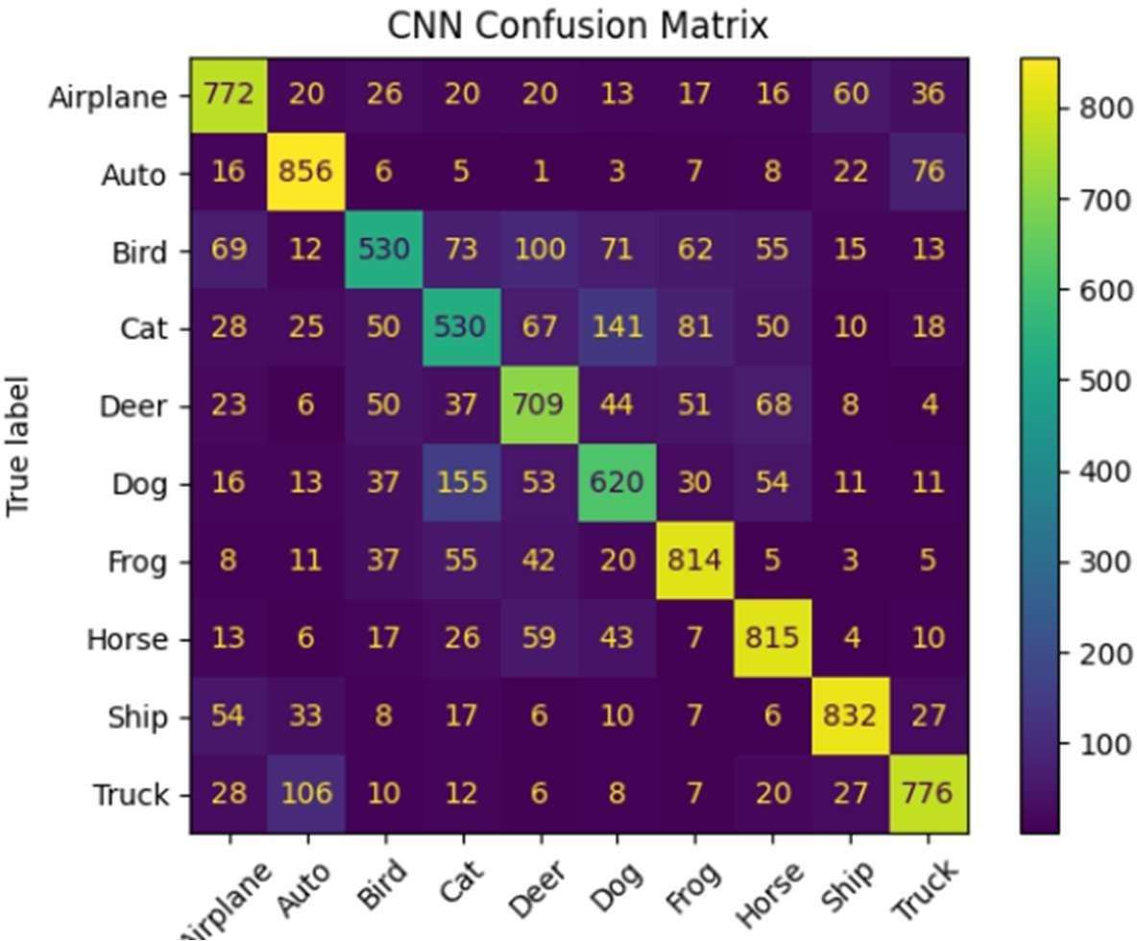
Figure 7. Confusion Matrix of CNN Classification Results

Discussion
The experimental results clearly demonstrate the security risks posed by adversarial attacks in deep learning systems. A highly accurate CNN model became extremely vulnerable when exposed to adversarial perturbations generated using FGSM.
The study further demonstrated that adversarial training can substantially improve model robustness against adversarial examples. Although some reduction in clean accuracy was observed, the adversarial trained model maintained significantly better performance under attack conditions.
These findings emphasize the importance of incorporating security-focused defense mechanisms into AI systems, particularly when deploying machine learning models in security-critical environments such as cybersecurity, autonomous systems, healthcare, and financial applications.

Limitations of the Study
Several boundaries limit the scope of conclusions drawn here. The architecture is intentionally compact; results on deeper residual networks or attention-based models may differ. All evaluations used single-step FGSM; multi-step methods such as Projected Gradient Descent typically penetrate defenses trained only on single-step perturbations. Experiments were restricted to CIFAR-10, a clean, well-balanced benchmark that may not reflect the noisier conditions of real deployment datasets. Finally, FGSM-based adversarial training provides empirical rather than certified robustness — there exist no formal guarantees that the model will resist all attacks within the perturbation budget.

Conclusion
This study pursued two concrete goals: measuring how completely a standard CNN classifier breaks under gradient-sign perturbation, and determining whether adversarial training can meaningfully restore its reliability. Both questions received clear empirical answers. The standard model, despite achieving 72.54% clean accuracy, was reduced to near-random performance at a perturbation budget smaller than what standard image compression routinely introduces. The adversarially trained counterpart — identical in architecture, trained for the same duration — retained over 28% accuracy at that same budget and demonstrated consistent improvements across all four evaluated perturbation levels. Confusion matrix analysis and visual adversarial example inspection corroborated these aggregate figures with class-level and sample-level evidence.
The central takeaway is practical: adversarial robustness is achievable through training procedure modification alone, without architectural redesign or specialized hardware. For practitioners deploying classifiers in adversarially realistic environments — autonomous systems, medical devices, security applications — adversarial training represents an accessible, evidence-backed first line of defense. It is not a complete solution, but it is a necessary starting point.

8.Future Work
Although the proposed defense mechanism improved robustness against FGSM attacks, several

opportunities remain for future research.
Future work may include Evaluation of additional adversarial attack techniques such as Projected Gradient Descent (PGD), DeepFool, and Carlini-Wagner attacks.
- Investigation of advanced defense mechanisms including robust optimization and certified defenses.
- Application of adversarial training to deeper neural network architectures. 3.Evaluation of robustness on larger and more complex datasets.
4.Exploration of adversarial threats in domains such as cybersecurity, autonomous systems, healthcare, and privacy-preserving AI.
These directions can further contribute to the development of secure, trustworthy, and resilient artificial intelligence systems.

9.References
- I. J. Goodfellow, J. Shlens, and C. Szegedy, “Explaining and Harnessing Adversarial Examples,” International Conference on Learning Representations (ICLR), 2015.
- A. Krizhevsky, “Learning Multiple Layers of Features from Tiny Images,” University of Toronto, Technical Report, 2009.
- Y. LeCun, Y. Bengio, and G. Hinton, “Deep Learning,” Nature, vol. 521, no. 7553, pp. 436– 444, 2015.
- N. Papernot et al., “Practical Black-Box Attacks against Machine Learning,” ACM Asia Conference on Computer and Communications Security, 2017.
- A. Madry et al., “Towards Deep Learning Models Resistant to Adversarial Attacks,” International Conference on Learning Representations (ICLR), 2018

